KARNATAKA STATE OPEN EDUCATION EXAMINATION BOARD (KSOEEB)
Under registration act XXI of 1960 GOVT.OF KARNATAKA.
APPLICATION FOR ACADEMIC/STUDY CENTER
ORGANIZATION PROFILE
1. Name of the Organization:
2. Year of Establishment:
(Please attach proof)
3. Type of Organization:
(Tick most appropriate)
Trust
LLP
Society
Pvt. Ltd
R & D Organization
Educational Institution
Bank / Insurance Co.
PSU/Govt. Organization
(Enclose the necessary
details and proofs)
Ltd
Others
4. Full Postal Address:
District:
Country:
5. Official Communication:
Phone No:
(Country Code)
(STD/Local Code)
State:
Pin Code:
Tele fax:
(Country Code)
(STD/Local Code)
Mobile No.: +91
email:
Fill the following and enclose prop er Proof:
6. Premises Details:
Owned
Rented
7. Ready for Operations:
Yes
Not Yet
8. Total Carpet Area of Organization (Sq. Ft.):
9. Total Site Area of Organization (Sq. Ft.):
10. Internet Connectivity:
Type
Server Computer
Client Computer
12. Infrastructure Details:
Generator
LCD Player
Units
FAX
Photo Copier
Area (Sq. Ft.)
Seating Capacity
Leased Line
Processor
Broadband
RAM
HDD
Dial-Up
Network (Y/N)
Speed
Internet (Y/N)
11. Details of Computers (Dedicated earmarked for Training and Research Purpose)
Sr. No. Other Infrastructure for Training Program
1 Class Rooms

2 Library (Total Books: ____________)
3
4

5

6
7
Reading Room/ Conference Room / Audio Visual Room
Administrative Area

Trainer Room

Service Area - Toilets etc.
Other ______________________
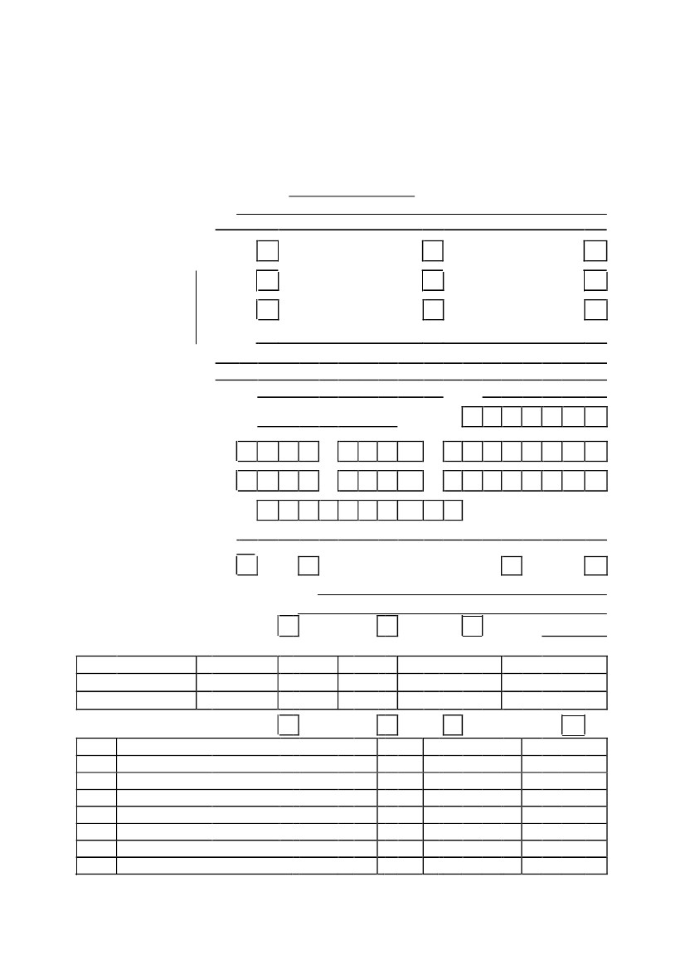
13. Detail of Courses that you are interested to offer through KSOEEB :
Sr. No. Proposed Course
1
2
3
4
5
6
(Use separate sheet, if necessary)
Expected No. of Sr. No. Proposed Course
Admissions
Expected No. of
Admissions
7
8
9
10
11
12
14. Teachers and other Staff Teaching Department Details:
Enclosed separate List of all Trainers and other Staff Members in following format:
Name | Father's Name | Date of Birth | Sex | Academic Qualification | Professional Qualification | Experience (Teaching & Non-
Teaching both) | Level of Association (Full Time/ Part Time/ Visiting Faculty) | Key Skills
DIRECTOR PROFILE

1. Name:
2. Designation:
3. Sex:
5. Experience :
6. Photo ID Proof : Driving License
(Kindly enclose the copy)
Latest Colour
Photograph in Passport
Size of the Proposed
Principal/Director
M
F
4. Qualification:
Passport
Voter ID
PAN Card
DECLARATION
We certify that the particulars furnished above or in the preceding pages are true to our best of our knowledge and express our willingness for an inspection to assess the infrastructural facilities, qualified staff etc. We declare that the Organization will abide by all the rules and directions of Karnataka State Open Education Examination Board (KSOEEB) given from time to time. In case of any information furnished by us is found wrong or incomplete in any regard, we shall be the responsible for any decision taken by KSOEEB. I hereby confirm that I will regularly visit/login website namely www.ksoeeb.com and any information relevant will be received by me from above-said website. Further, I will never claim any information officially or unofficially in hard copy and email. Therefore, only I will be responsible for all types of consequences, if I don't visit/login the said website.
I have carefully read and understood all the guidelines, specifications and other information published by the KSOEEB on the Website www.ksoeeb.com In case of any disputes or for any unforeseen issue(s) or issues not covered in the guidelines, specifications and other information published by the KSOEEB, the decision of the KSOEEB shall be final and binding on me and all other concerned. I agree that the KSOEEB reserves the right to withdraw any location or any Discipline/Programme or its nomenclature at any time without assigning any reason and to make modifications in any information published anywhere whenever deemed necessary.
In the event of any disputes between the parties, which are not covered at the arbitration clause, the courts of Karnataka shall have exclusive jurisdiction.
Date:
Specimen Signature of the Proposed Principal/Director
Seal & Signature of the Head of the Organization

FOR STUDY CENTRE USE ONLY
Allotment Fee of Rs. 25,000/-
(Non-Refundable and Non-Adjustable) in favour of "KARNATAKA STATE OPEN EDUCATION EXAMINATION BOARD" payable at Bangalore
Demand Draft No.
Date
Bank
Issuing Branch
Kindly allot me the following selected Progammes :
1) 10TH (Equalant to SSLC)
2) 12th Standard (Equalant to PUC-II)
PHOTOS TO BE PASTED:
Space for Affixing
‘WIDE RANGE PHOTOGRAPH SHOWING THE LOCALITY OF THE ORGANISATION’
UNDERTAKING

The above pasted photographs are belonging to our Organization. I also undertake that if I fail to pay renewal fee for Study Centre/Coordinator then KSOEEB have the right to transfer all our enrolled Students to any other Regional Coordinator or treat them as Direct Students to complete their course.
I understand and agree that fees paid by me with the application form or on account of processing fee, for conduct of inspection, for grant of approval of my application or any other fee or charges, as prescribed for Study Center once paid, will be non-refundable. Withdrawal of my proposal or rejection by the KSOEEB at any stages for reason whatsoever shall not entitle me to claim any amount or compensation from the KSOEEB.
Signature of the Proposed Principal/Director
Seal & Signature of the Head
KINDLY SUBMIT ACADEMIC/STUDY CENTER FORM TO :

KARNATAKA STATE OPEN EDUCATION EXAMINATION BOARD (KSOEEB)
2nd Floor, Oswal Tower, Jubilee Circle Dharwad - 580001
Contact : 08362740620 / 8453482436

KARNATAKA STATE OPEN EDUCATION EXAMINATION BOARD (KSOEEB)
UNDER REGISTRATION ACT XXI OF 1960 (GOVT.OF NCT OF KARNATAKA)
INFORMATION OF ORGANISATION
Name of the Organisation
Type of Organisation
Registered Address
Date of Registration
Registration Number
Pan card No
Proposed Office Address
List of Office Bearers
President/Chairman
Mobile No
Authorised Person
Phone No. with STD Code
E-mail Address
Fax
……………………………………………………………………….
……………………………………………………………………….
………………………………………………………………………..
……………………………………………………………………….
……………………………………………………………………….
………………………………………………………………………..
………………………………………………………………………
………………………………………………………………………
………………………………………………………………………
………………………………………………………………………
……………………………………………………………………….
……………………………………………………………………….
………………………………………………………………………..
DOCUMENTS TO BE ATTACHED
➢
➢
➢
➢
➢
➢
➢
➢
Organization Registration Certificate Copy
Organization PAN Copy
Organization Head PAN Copy
Organization Head Id Proof Copy
Organization Building Ownership Proof/Rent Deed
Organization Building Photograph.
Organization Building Map
List of Staff members

